# John Doe Portfolio – User’s Manual

An insight into John Doe’s professional, technical, and personal experience.

## Table of Contents

Introduction 3

Main Content: 3

Cross Platform Compatibility: 3

Technical Definitions: 4

Technical Component Description: 5

Navigation Bar: 5

Title Cards: 6

Application / Programs: 7

View Source Code: 8

Contact Page: 9

Conclusion: 10

Authors: 10

# Introduction

Welcome to the John doe – Portfolio version 1.0.

The John Doe portfolio offers a seamless experience for our users to effectively navigate the repository of information and community outreach. This user manual will serve as a comprehensive guide to a user’s navigation throughout the portfolio of John Doe. To begin the John doe – Portfolio version 1.0 will only address the online website applications and its features that compose its primary functions.

The homepage serves as the primary gateway for our users. We understand the significant role and importance of our central navigation hub when users hope to effectively navigate throughout the website.

The mobile website is comprised of 5 prominent features that serve as the core foundation. These features are integral to website functionality and play a pivotal role in shaping a diverse user experience.

This user manual will provide a comprehensive overview of the following five key features, as well as providing quick insight into the metrics regarding run time, lines of code and other technical components.

* Navigation bar
* Title cards
* Application / programs
* Contact
* Program code

# Main Content:

## Cross Platform Compatibility:

The John Doe Portfolio is compatible with all mobile devices that can access the web and it pages. Down below is a condensed list of popular compatible devices.

* iPhones
* iPad
* Android phones
* Android tablets
* PC
* Laptops

## Technical Definitions:

Mobile application: A software program explicitly developed for the execution on mobile compatible devices. Applications crafted using platform-specific programming languages and frameworks tailored to the operating system of the utility device.

Programming languages: A formal language comprising of rules and symbols that are used to create sequences of instructions that are executable by a computer. Different programming languages are optimized for various tasks, leading to different syntax, writing style, and utilization.

Example of Programming languages:

* JavaScript
* Python
* HTML & CSS

Client side: A part of the software application that runs on the user device. Encompassing the code and process that are executed locally on the user-side machine. Local client side refers to text, images, and the rest of user UI.

Server side: A part of the software application that runs on the data server. Handling the process, management of data and information with the client users. Responsible for fulling the user client-side request and preset data.

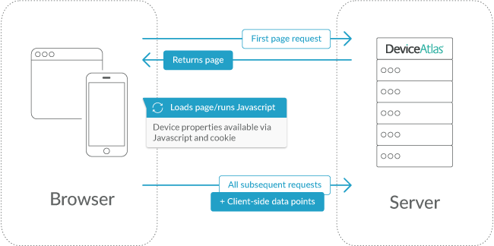

## Technical Component Description:

Average Runtime: 2s

Lines of Code: 1995

## Navigation Bar:

The John Doe navigation bar plays a vital role in users navigation throughout the portfolio extensive repository of information, facilitating the exploration of the numerous application and features.

The navigation will direct the user to John Doe’s Personal information, projects, and Contact page

The search navigation is possible by the combination of client-side requests and server-side data management.

Client-side Request:

JavaScript is a client side lightweight, object-oriented programming language that is commonly used for the development of web applications, along with mobile applications.

It is responsible for handling client-side user interaction, such as capturing user input typed input. As well as, dynamically updating search suggestions.

## Title Cards:

John Doe featured titles cars are static category options located directly underneath the profile of John Doe

These Featured categories are specifically selected based on John Doe’s selected featured programs to showcase users

Featured categories are static redirection options.

Similar to the navigation bar, we use client-side requests and server-side data processing to interact with featured categories.

Instead of captured user specific input, the client-side request would be determine based on the “clicked” featured category.

## Application / Programs:

Applications and programs are dynamic showcases of John Doe’s prominent featured programs and skills. Each application is an interactable program / application that can be dynamically changed based on user inputs.

## View Source Code:

The Source Code button allows access to a real time – updatable webpage the displays the code necessary to run the program and featured content.

Every program will have at the top right of the page a redirection link to view this webpage displaying the all the source code for the program and website

## Contact Page:

The Contact Page offers of the John Doe portfolio offers user of the website to directly contact John Doe.

These messages will be filtered and sent via email. Directly to John Doe

# Conclusion:

The John Doe Homepage is comprised of 5 key features. Seamlessly integrated together to create a streamlined user interface. Having a strong foundational understanding of the homepage empowers users to explore the numerous features provided by the webpage.

The Homepage is primarily composed of redirection features. These dynamic showcases redirections give extensive information about John Doe and his ability as a programmer. Because of the homepage redirection showcase we can view the extensive other parts / elements beyond the homepage.

The parts and subparts fit together seamlessly as they comprise a majority of the website and application. Client-side is a prominent topic throughout this user manual because the subpart can be found in universally all the features present portfolio

## Authors:

* Jack Dodge
* West Manison
* George Morales
* Sebastian Sanchez